This Club, The Scugog Shuffleboard Club Holds Their Annual Picnic
Posted on 2017-08-25 by stanistheman
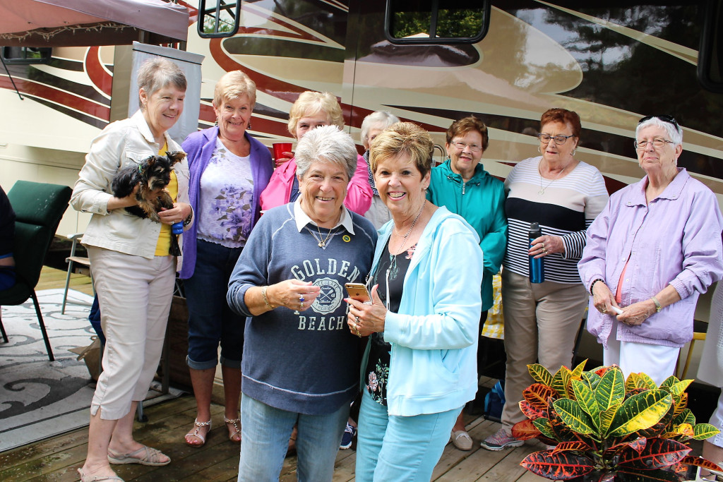
Discrimination in Favour of Women; Equal # of Men + 3 Present!!
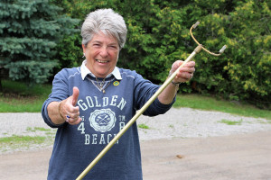
Ann Davies. click on pic
Ann Davies, the current President of the Blackstock (Scugog) Club invited Lois and I to attend their Annual Picnic in Dunsford ON, a mere 3 and 1/2 hour drive from Calabogie. We did, and we are OH so glad we accepted her invitation. Engaging in conversation, renewing friendships, and meeting new friends is the prime motivator, the greatest enjoyment in such events. Second comes the great variety of food, topped of by the Supersized Hot Dogs BBQd by our host Bob Davies. Most enjoyed a game of Bocce Ball, either before or after lunch. Stan, always thinking historically, read his report of an earlier (2004) Scugog Picnic at the residence of Nancy and Bob Bryans. Scugog Picnic 2004
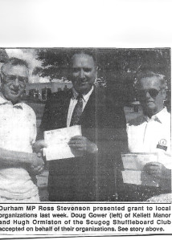
Hugh, on our right, accepts the GRANT.
The Cue that Ann is PROUDLY holding in the pic above, is her fathers, Gerald Balson. GERALD BALSON LEAVES US up
The Scugog Club in Blackstock has a significant history. It was founded in Port Perry Ontario and moved to Blackstock prior to 1993. I have a pic of Hugh Ormiston accepting a “federal New Horizons Grant” in the amount of $15,128.00 from MP Ross Stevenson. Hugh was the very first President of the Scugog Club; he was introduced, honoured, by Past President John Heron during the ceremonies of the Scugog Spring Fling of 2006. (click on any pic to expand)
I am now going to give you a newspaper article c/w pix of Aug. 5th,
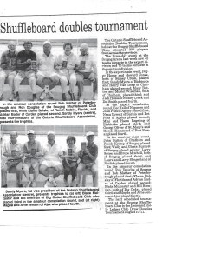
230 Players in OSA Tournament in Blackstock, ON
1993. It is the newspaper reporter’s take on a Tournament that attracted 230 Shufflers from across the province!!! Got that?? 230 Players!!
To view this article, (230 Players in OSA T. in Blackstock) 1st, click on it once; pause and click on it once more. To move the article, place your cursor in the centre, and move it left or right, or up and down. To pause in an area you would like to read, see the dark line at the very bottom, put your cursor on it, and move article whe
re you would like. BE sure and “work with it”. It is most readable!! It is a part of our Shuffleboard History.
Stan McCormack. 2017 08 25.

